60 mins  Sound and Waves Test 2013 [60] marks

Name:

**Question 1 [10 marks]**

The graph shown below represents a sound wave moving in air at 25**°**C.

disp (mm)

2

1 2 3 4 5 6 7 8 9 10 time (ms)(

-2

(a) Determine each of the following quantities for this sound wave. [4 marks]

Amplitude A = Period T =

Frequency f = Wavelength λ =

(b) Which of the quantities amplitude, frequency and/or wavelength would remain constant if the sound wave crossed from air into water? Explain your answer. [3 marks]

(c) Complete the sketch below by showing how the sound wave behaves as it meets the boundary between the air and water at a slight angle to the normal. [3 marks]

**air**

**water**

**Question 2 [9 marks]**

The didgeridoo is a traditional Aboriginal wind instrument. It is a hollow pipe, open at both ends, and usually about 1.5 m long. The didgeridoo has no holes, keys or valves like orchestral wind instruments have, but overtones or harmonics may be sounded by overblowing (blowing more strongly).

(a) Draw the standing wave (displacement-distance envelope) produced when the instrument is blown so that the second overtone is heard. Label each node and antinode. [2 marks]

(b) Given that the speed of sound in cool desert air is 336 m/s, calculate the frequency of the second overtone produced from a 1.50 m long didgeridoo. [2 marks]

(c) Determine the frequency of the fundamental note from this didgeridoo. [1 mark]

(d) A second didgeridoo sounds its fundamental note of frequency 107 Hz. Which of the two instruments is longer? Explain. [2 marks]

(e) If the original instrument and the second instrument are both sounded together at the same loudness, describe the sound that would be heard. Include a simple numerical calculation in your answer. [2 marks]

**Question 3 [4 marks]**

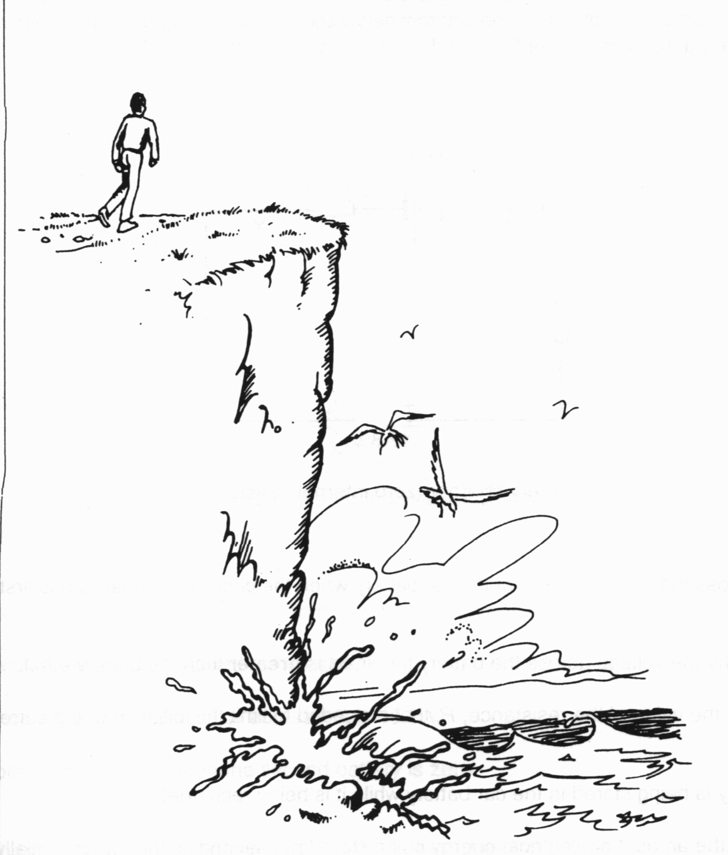

You are walking along a path on a cliff above a beach. The path is not quite on the cliff edge, so you cannot actually see the surf, nor can you see the seagulls that are flying below the cliff. Explain why you **can** hear the pounding of the surf, but you **cannot** hear the cries of the seagulls.

**Question 4 [7 marks]**

Two loudspeakers are 8.00 m apart and emitting a frequency of 230 Hz in air where the speed of sound is 345 m/s. The speakers are in phase with each other and face towards each other. A person hears a series of quiet and loud spots as they walk from one speaker towards the other.

(a) What does “in phase with each other” mean? [2 marks]

(b) What is the distance between a quiet and loud spot? [2 marks]

(c) What will be heard by someone who is between the two speakers and 3.25 m from one of the speakers? [3 marks]

**Question 5 [7 marks]**

A signal generator is connected in phase to two loudspeakers that are 3.0 m apart in a room. A person stands in front of the midpoint between the speakers as shown at right.



(a) Why does the person hear a loud sound at the midpoint between the speakers? [2marks]

The person then moves slowly to the right. At point X along this path, the sound reaches a minimum. Beyond point X the sound increases in strength again, then decreases, and continues to alternate in strength as they move steadily to the right.

(b) Explain why the person hears the sound level alternate as he moves to the right. [2marks]

(c) Calculate the frequency of the sound coming from the sound generator. [3 marks]

**Question 6 [4 marks]**

An opera singer sings a pure note next to a piano and notices that when he stops some strings on the piano have begun to vibrate. Explain why the strings begin vibrating.

**Question 7 [8 marks]**

The outer human ear can be modelled as a pipe 27 mm long and closed at one end. Sound entering the ear travels along the tube and is reflected back causing a standing wave in the tube.

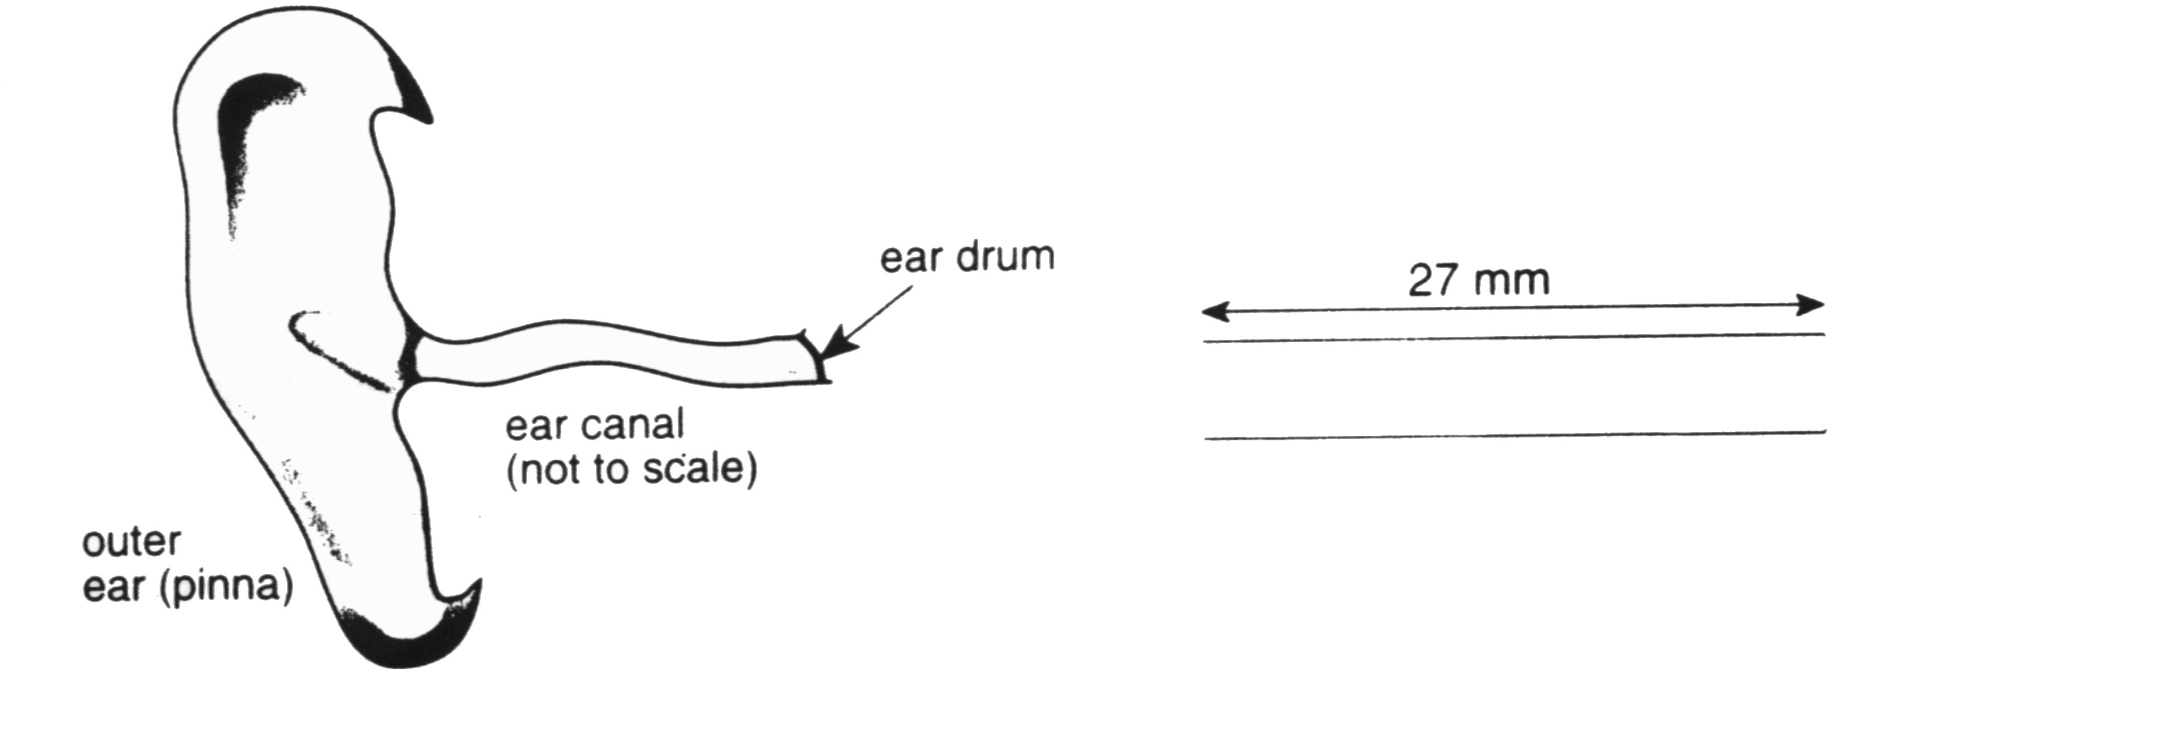

(a) Use the diagram above right to draw the wave pattern for the first mode of vibration. Label each node and antinode. [2 marks]

(b) Is this standing wave produced transverse or longitudinal? Explain. [2 marks]

(c) Calculate the wavelength of this standing wave, and its frequency in air at 25**°**C. [2 marks]

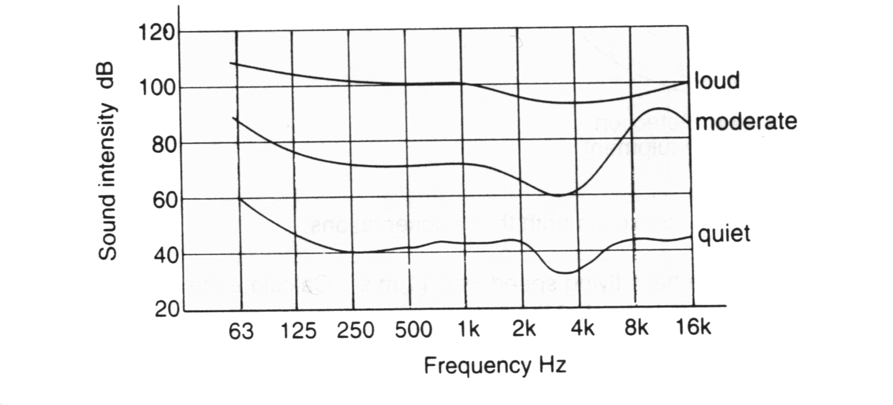

(d) The graph at right shows how the perceived loudness (sound intensity) of a sound depends on its pitch (frequency). Explain whether the graph supports the calculation in part (c) above. [2 marks]

**Question 8 [11 marks]**

An experiment to investigate the relationship between the tension in a guitar string and the frequency of transverse waves in the string is set up using apparatus like that shown below. The frequency oscillator is used to vary the rate at which the **1.20 m long** string is forced to vibrate.

m

Frequency Oscillator

Pulley wheel

Mass providing the tension in the string

Using this apparatus the mass providing the tension in the string was altered over several trials; each trial the frequency was varied until resonance occurred and produced the fundamental standing wave pictured above. The results are shown in the table below.

|  |  |  |  |  |  |  |
| --- | --- | --- | --- | --- | --- | --- |
| mass m (g) | 100 | 200 | 300 | 400 | 500 | 600 |
| frequency f (Hz) | 175 | 250 | 305 | 350 | 395 | 430 |
|  |  |  |  |  |  |  |

For a stretched string of given mass per unit length μ and under tension F, the velocity v of a wave in the string is given by the equation: 

(a) Using this equation, the equation for the fundamental frequency of waves on a string and the equation for the weight of a mass, derive the following relationship between frequency f and mass m (note L is the string length and g is the acceleration due to gravity) [3 marks]

f 2 = (g/4L2) m

(b) Modify the data in the table above so that you can plot a straight-line graph to show this relationship between frequency and mass. Plot the graph below [4 marks]



(c)From your graph, determine the mass per unit length (μ) of the guitar string. [4 marks]

**END OF TEST**